

American International University - Bangladesh
Department of Computer Science
Web Technologies
Project Report
Fall 2025-2026

Course Title | Web Technologies | Section | R | #Group | 16
Group Member:
Serial | Student ID | Name | Project Number
1. | 23-51087-1 | Grontho Chandra Roy
33 | 23-51934-2 | Sadia Islam

Project Title: Online Bookstore Management System

Project Description:
The Online Bookstore Management System is a web-based application developed to automate and digitalize the traditional book purchasing process. It provides an interactive online platform where users can browse a wide range of books, view detailed information, add items to a cart, and complete purchases securely from anywhere.
The system includes a dedicated user panel that allows customers to register, log in, search books by category, view latest arrivals, popular books, and discounted items, and track their order history. A smooth checkout process ensures users can place orders by providing basic delivery and payment information, after which a unique order ID is generated for confirmation.
An integrated admin panel enables administrators to efficiently manage the entire system. Admins can add, update, and delete books, manage categories, apply discounts, monitor stock levels with low-stock alerts, view registered users, and generate sales reports for business analysis. This centralized management reduces manual effort and ensures accurate data handling.
The application is developed using HTML, CSS, and JavaScript for the frontend, PHP for server-side processing, and MySQL for database management. Secure authentication mechanisms and dynamic data fetching ensure data integrity, reliability, and a smooth user experience. Overall, this system improves efficiency, enhances usability, and provides a scalable solution for modern online book retailing.

1. User Interaction Section
1.1 Home Page (User View)
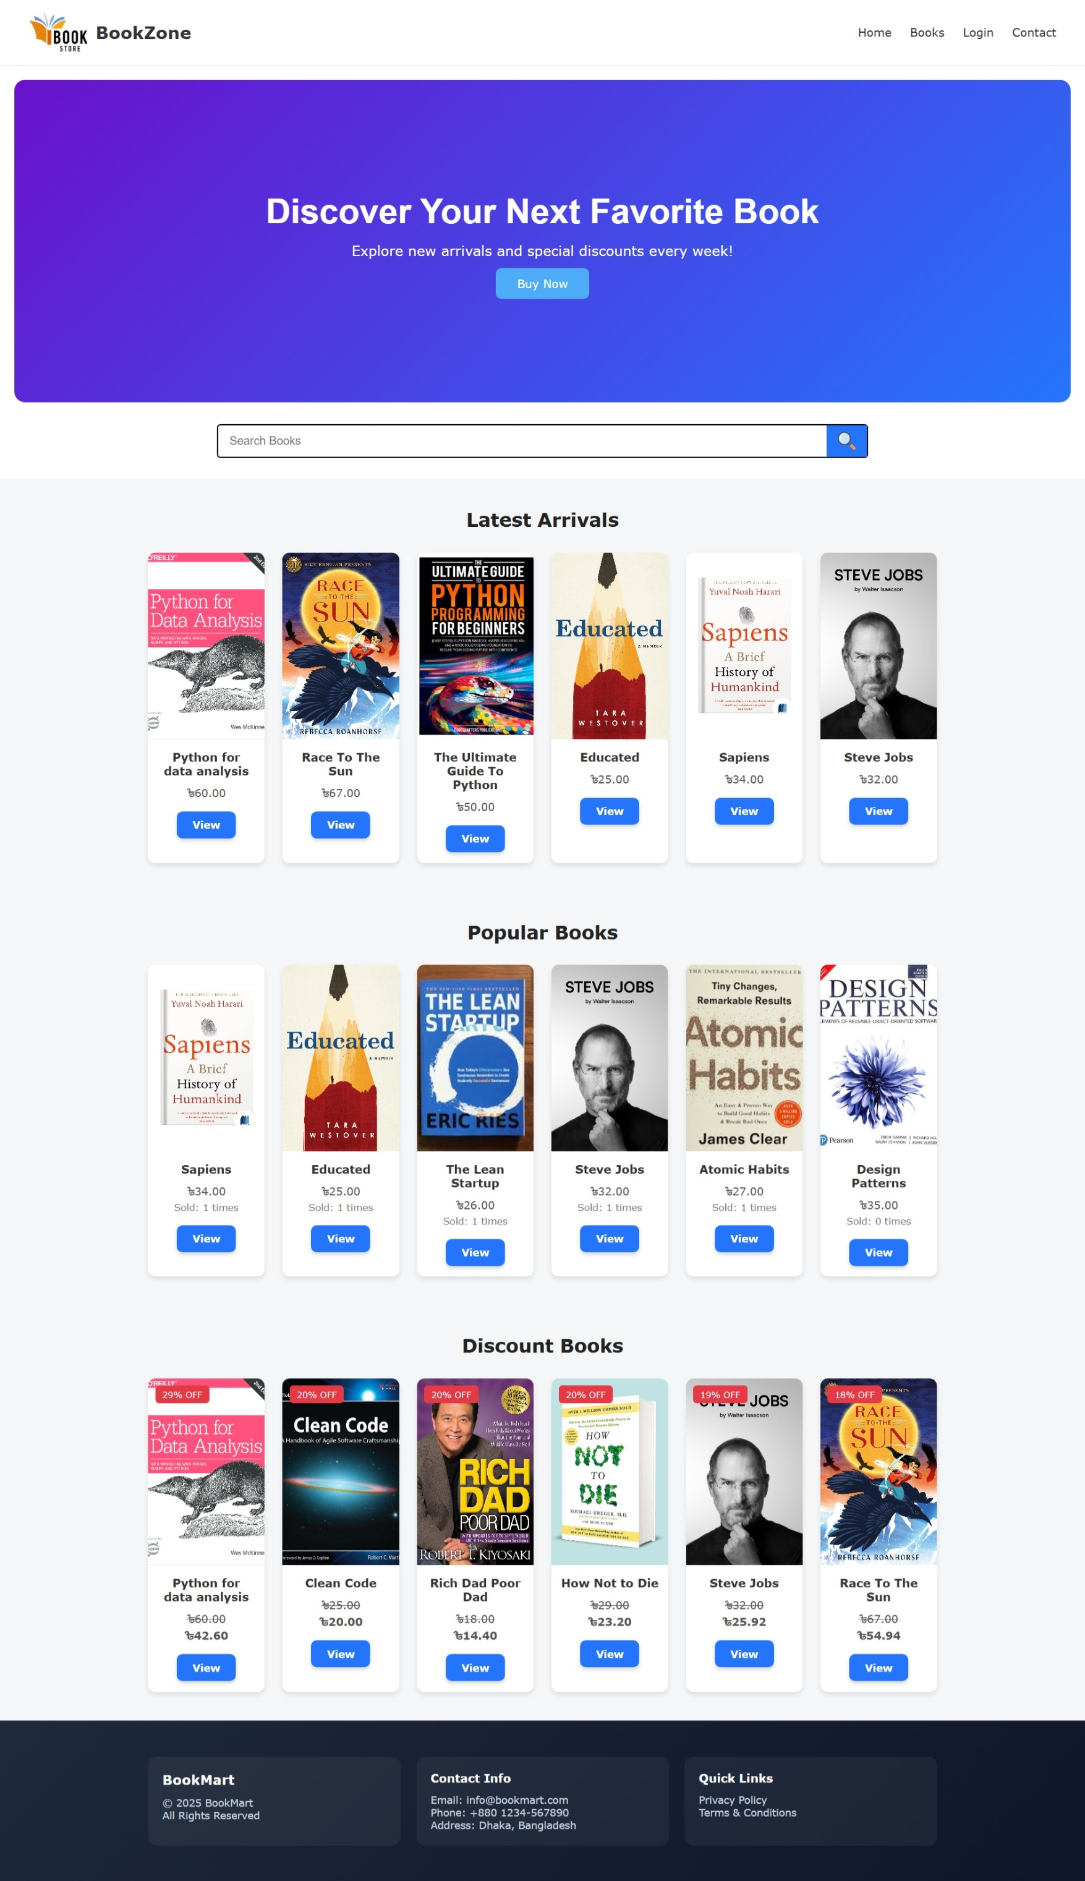
Description:
The home page is accessible to all users without login. It displays books in different sections such as:
- Latest Arrival
- Popular Books
- Discount Books
It also contains navigation options like Home, Books, Contact Info, Login, and Logout.

1.2 Books Listing Page

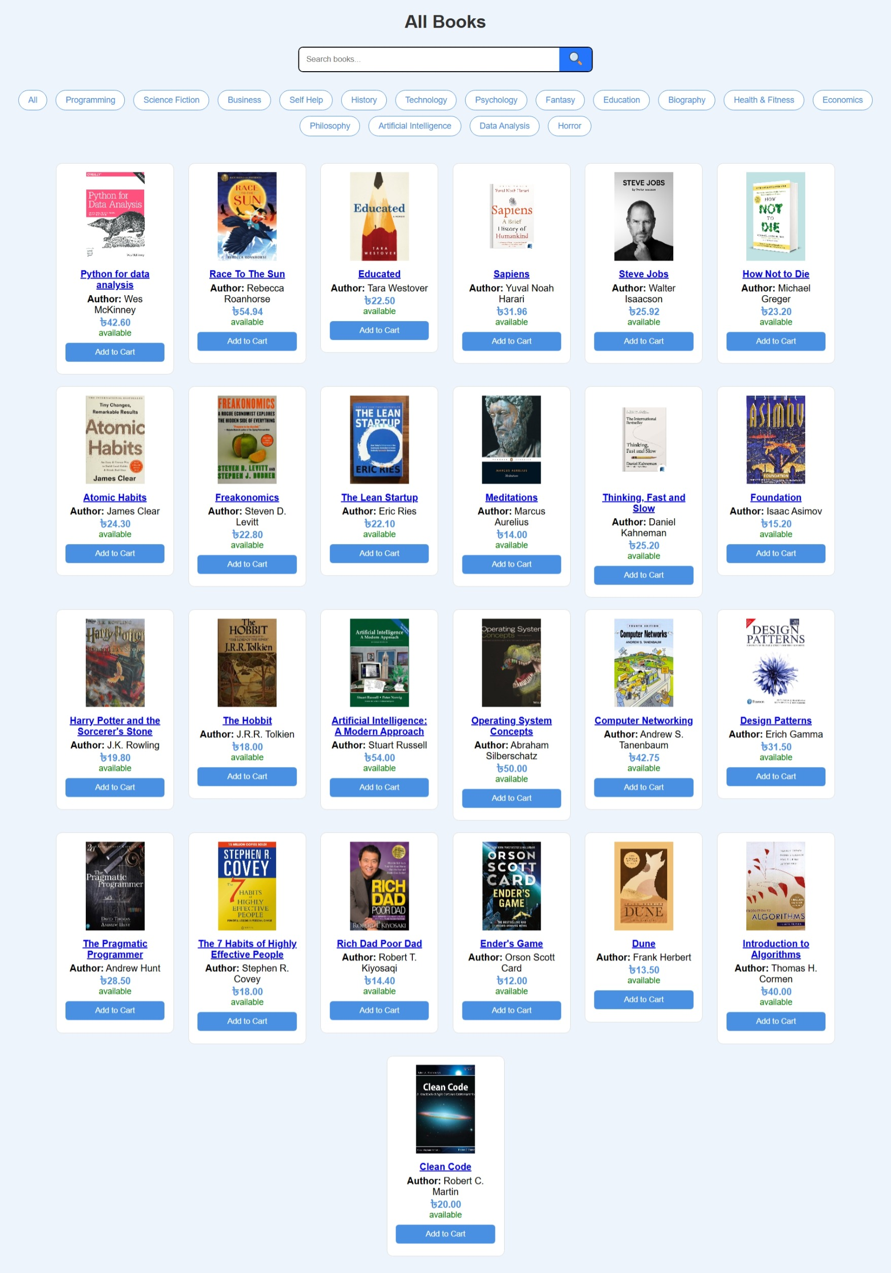
Description:
Users can view all available books. Each book card shows:
- Book title
- Price
- Discount (if available)
- “Add to cart” button
Users can click on any book to view detailed information.

1.3 Book Details Page
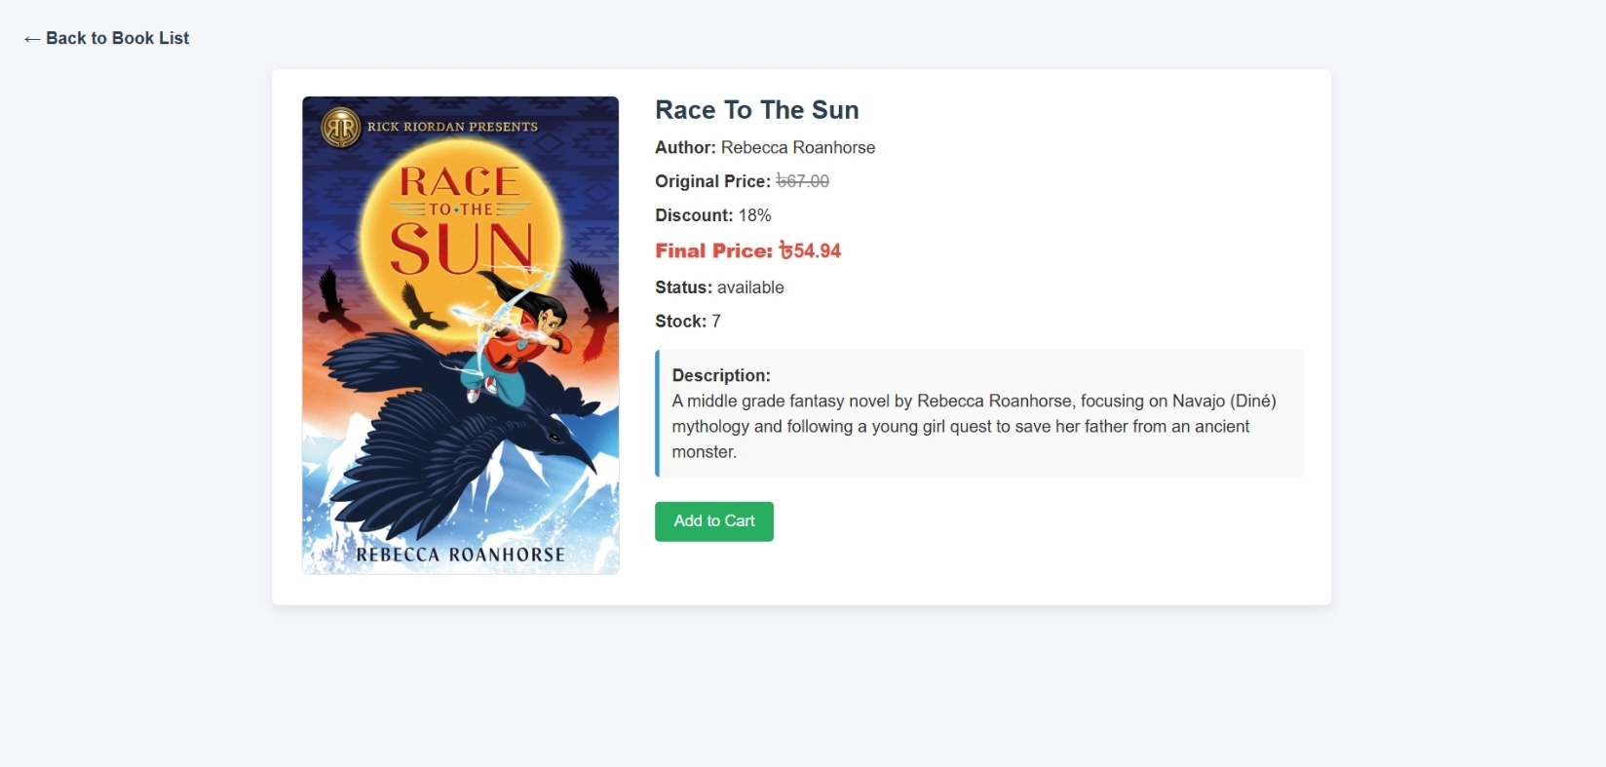
Description:
This page displays detailed information of a selected book including:
- Book description
- Author name
- Price
- Discounted price
- Stock availability
Only registered users can add books to the cart.

1.4 User Registration & Login
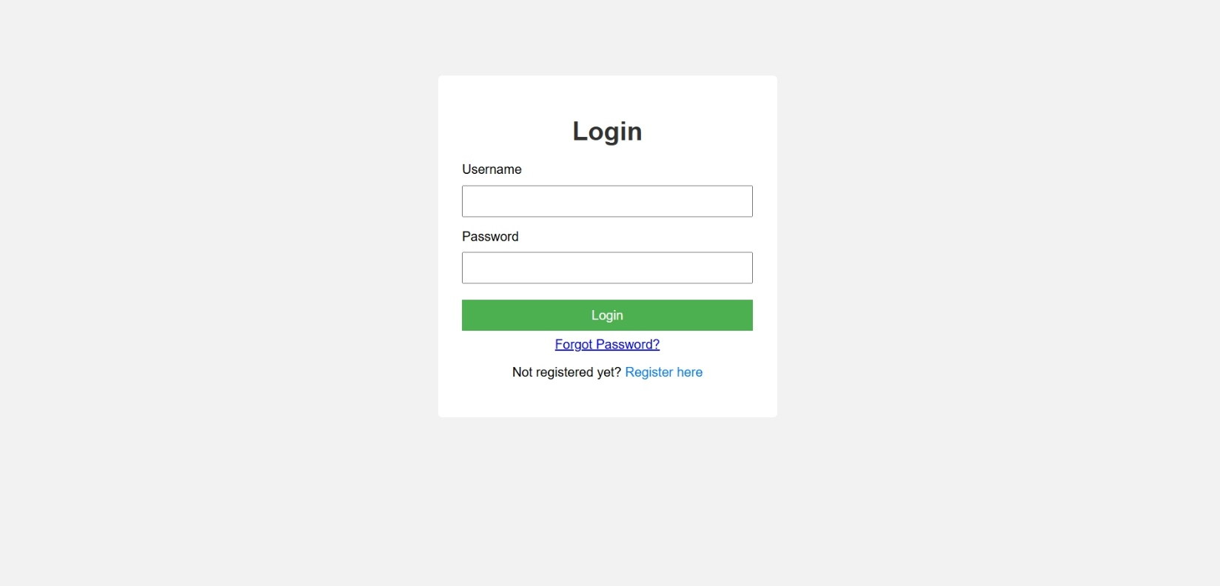

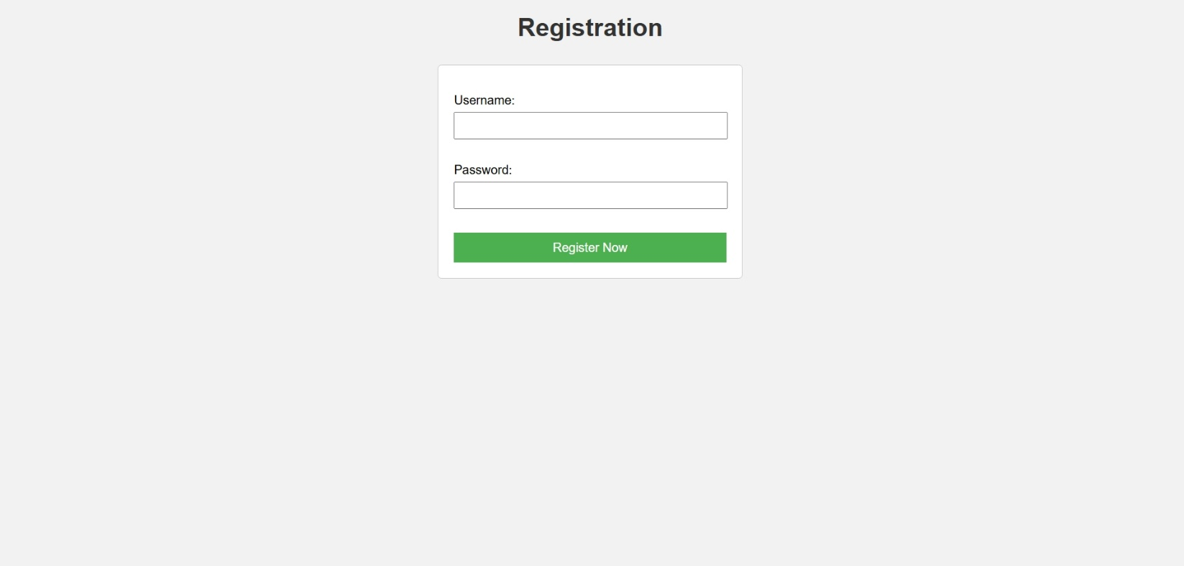
Description:
If a user wants to purchase a book, registration is required.
After successful login, users can:
- Add books to cart
- Proceed to checkout
- View order history
1.5 Forget Password
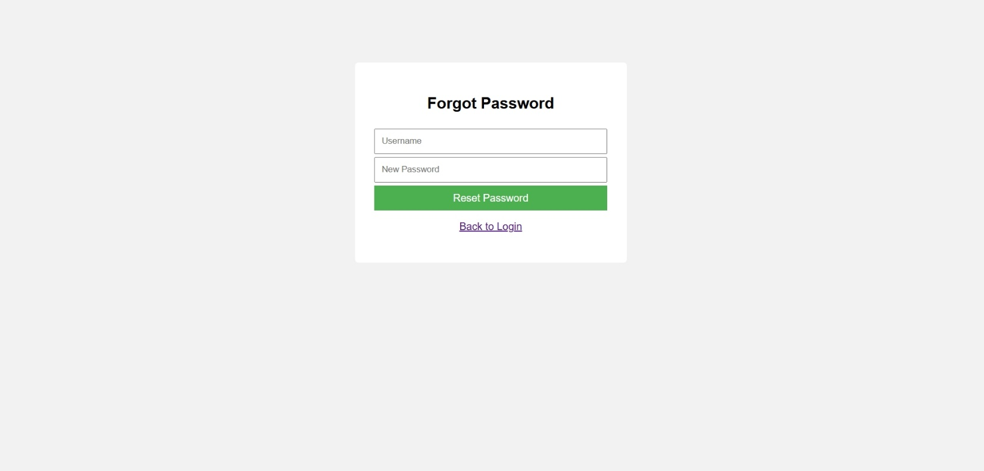
Description:
If a user forget password, new password can be set using user name.
- If a user is not registered, cannot change the password

1.6 Cart & Checkout Process
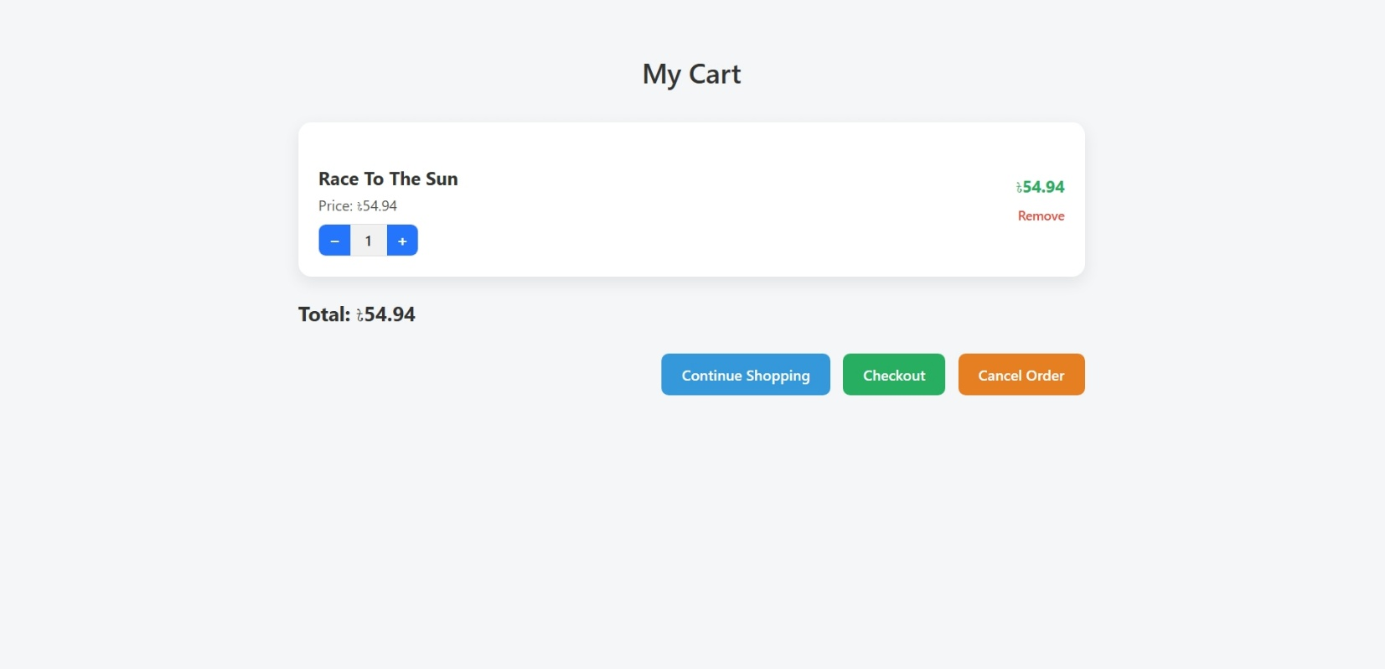
Description:
Users can view selected books in the cart, update quantity, or remove items before proceeding to payment.

1.7 Payment & Order Confirmation
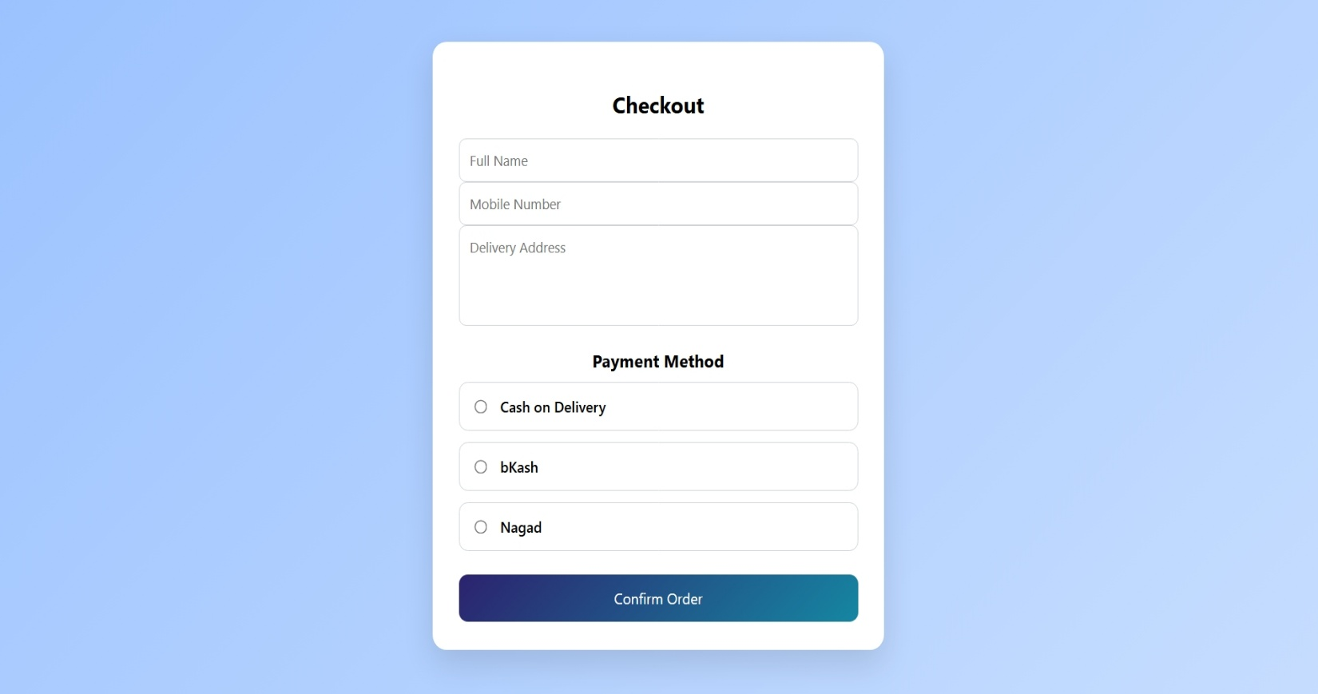
Description:
Users provide:
- Name
- Mobile number
- Address
Users choose a payment option
- Cash on delivery
- Bkash
- Nagad
For Bkash and Nagad user provide number.
After confirming the order, the system generates a unique Order ID which tells payment method and total amount.


1.8 Order History (User)
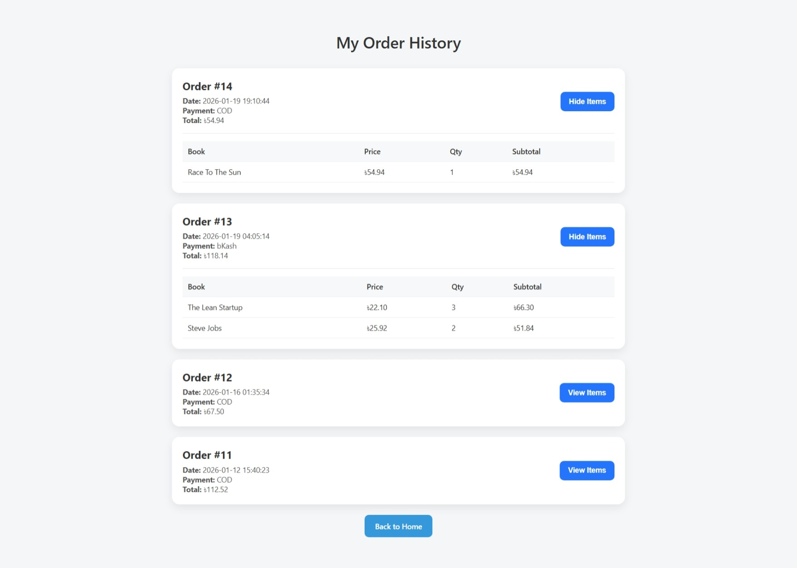
Description:
Logged-in users can view their previous orders along with:
- Order ID
- Order date
- Total amount
- Payment method
- Books details include (book name, price, quantity, total amount)

2. Admin Interaction Section
2.1 Admin Dashboard
Screenshot 9: Admin Dashboard
Description:
The admin dashboard provides an overview of the system including:
- Total users
- Total books
- Orders summary

2.2 User Management
Screenshot 10: Registered Users Page
Description:
Admin can view all registered users and monitor user activity.

2.3 Book Management
Screenshot 11: Book Management Page
Description:
Admin can:
- Add new books
- Update existing books
- Delete books
- Set discounts
- View low stock alerts
Low stock warnings help prevent out-of-stock issues.

2.4 Category Management
Screenshot 12: Category Management Page
Description:
Admin can add, update, or delete book categories, which helps organize books efficiently.

2.5 Sales Report Generation
Screenshot 13: Sales Report Page
Description:
Admin can generate sales reports based on orders.
The report shows:
- Total sales
- Order details
- Date-wise transaction data
This helps in business analysis and decision-making.

3. Technologies Used
- Frontend: HTML, CSS, JavaScript
- Backend: PHP
- Database: MySQL
- Server: Apache (XAMPP)

4. Conclusion
The Online Bookstore Management System successfully provides a complete online solution for book purchasing and management.
Users can easily browse, buy books, and track orders, while administrators can efficiently manage inventory, users, categories, and sales reports.
This project demonstrates practical implementation of web development concepts and database-driven applications.

